STORM WATER MANAGEMENT PROGRAM PLAN
January 2022

Prepared For
City of Tarrant
1604 Pinson Valley Parkway
Tarrant, Alabama 35217

Prepared by
Jefferson County Department of Health
1400 Sixth Avenue South
Birmingham, Alabama 35233
(205) 930-1230

Signatory and Certification Requirements:
I certify under the penalty of law that this document and all attachments were prepared under my direction or supervision in accordance with a system designed to assure that qualified personnel properly gather and evaluate the information submitted. Based on my inquiry of the persons who manage the system, or those persons directly responsible for gathering the information the information is to the best of my knowledge and belief, true, accurate, and complete. I am aware that there are significant penalties for submitting false information, including the possibility of fine and imprisonment for knowing violations.

___________________________________ | _________________
Wayman Newton | Date
Mayor, City of Tarrant

Address: 1604 Pinson Valley Parkway
Tarrant, Alabama 35217

Phone: (205) 849-2800

Contents
Introduction 10
Regulatory Overview 10
MS4 Jurisdictional Boundary 11
Legal Authority and Enforcement 11
Storm Water Collection Systems Operations 16
Structural Controls Mapping 16
Structural Controls Inspection 16
Standard Operational Procedure (SOP) for Structural Control Inspection and Maintenance Procedures 16
Stabilization and Re-vegetation of Eroded Areas 16
Floatables, Litter, Sediment and Debris in Structural Controls 17
Public Education and Public Involvement on Storm Water Impacts 18
Development and Implementation of the SWMPP 18
Public Access to City Storm water Documents 18
Targeted Pollutant Sources for Public Education 18
Reduction of Litter Floatables and Debris 18
Educating Individuals and Households on Reducing Storm Water Pollution 19
Community Involvement with the Storm Water Program 19
General Public 19
Businesses 20
Homeowners, Landscapers, and Property Managers 20
Engineers, Contractors, and Developers 21
Evaluating the Effectiveness of the Public Education Program 21
Public Awareness Activities 21
Illicit Discharge Detection and Elimination (IDDE) 22
MS4 Map 22
Ordinance/Regulatory Mechanism 22
Dry Weather Screening 22
Source Identification 23
Illicit Discharge Elimination 23
ADEM Notification by the City 23
Illicit Discharge Reporting by the Public 23
Personnel Training 24
Ordinance/Regulatory Mechanism Availability 24
Construction Site Storm Water Runoff Control 25
Erosion and Sedimentation Control Complaints 25
Site Plan Reviews 25
Site Inspection Plan 25
Training of MS4 Site Inspection Staff 25
Construction Site Inspection Checklist 26
Enforcement Response Plan (ERP) 26
Construction Site Operator Training 26
Post-Construction Storm Water Management in New Development and Re-Development 27
Ordinance/Regulatory Mechanism 27
Inventory of Post-Construction Structural Controls 27
Spill Prevention and Response 28
City Response Protocol 28
Spill Prevention/Spill Response Plan 28
Personnel Spill Prevention/Response Training 28
Pollution Prevention/Good Housekeeping For Municipal Operations 29
Municipal Facilities Inventory 29
Good Housekeeping Practices SOP 29
Inspection Plan 29
Good Housekeeping Training Program 29
Short Term and Long Term Trash Removal Strategy 29
Application of Pesticides, Herbicides, and Fertilizes (PHFS) 31
Application and Storage 31
PHF Training Program 31
Oils, Toxics, and Household Hazardous Waste 33
Public Education on Proper Disposal 33
Annual Employee Training 33
Industrial Storm Water Runoff 34
Inventory of High Risk Facilities 34
Inspection of High Risk Facilities 34
Wet-Weather Monitoring and Reporting 36
Monitoring Locations 36
Impaired Waterways 36
Monitoring Parameters and Frequency 37
Sampling Type Collection and Analysis 37
Other Requirements 39
SWMPP Plan Review and Modification 39
Annual Report 39

LIST OF FIGURES
Figure 1: MS4 Boundary 15
Figure 2: PHF Usage Sites 32
Figure 3: Industrial and High Risk Facilities 35
Figure 4: Sampling Sites 38

LIST OF TABLES
Table 1: Municipal Facilities 30

APPENDICES
Appendix A – Tarrant Storm Water Program Documents
Appendix B - Storm Water Collection Systems Operations
Appendix C - Illicit Discharge Detection and Elimination (IDDE)
Appendix D - Construction Site Storm Water Runoff Control
Appendix E - Spill Prevention and Response
Appendix F - Pollution Prevention/Good Housekeeping for Municipal Operations
Appendix G – Industrial Storm Water Runoff

Introduction

Regulatory Overview
The City of Tarrant (City) was issued by the Alabama Department of Environmental Management (ADEM) a Municipal Separate Storm Sewer System (MS4) Individual Phase I Permit (ALS000020) on June 7, 2017 (Appendix A). This permit went into effect on July 1, 2017. Previously, the City was included as a Co-Permittee under permit number ALS000001.
As a condition of this permit, “The permittee is required to develop, revise, implement, maintain and enforce a storm water management program (SWMP) which shall include controls necessary to reduce the discharge of pollutants from its MS4 consistent with Section 402(p)(3)(B) of the Clean Water Act and 40 CFR Part 122.26. These requirements shall be met by the development and implementation of a storm water management program plan (SWMPP) which addresses the best management practices (BMPs), control techniques and systems, design and engineering methods, public participation and education, monitoring, and other appropriate provisions designed to reduce the discharge of pollutants from the MS4 to the Maximum Extent Practicable (MEP)”.
Per the requirements of NPDES Permit Number ALS000020, BMPs, measurable goals, and responsibility designations are provided for each of the following program elements:
- Storm Water Collection System Operations
- Public Education and Public Involvement on Storm Water Impacts
- Illicit Discharge Detection and Elimination
- Construction Site Storm Water Runoff Control
- Post-Construction Storm Water Management in New Development and Re- Development
  - Spill Prevention and Response
  - Pollution Prevention/Good Housekeeping for Municipal Operations
  - Application of Pesticides, Herbicides, and Fertilizers
  - Oils, Toxics, and Household Hazardous Waste Control
  - Industrial Storm Water Runoff

ADEM defines the fiscal year as October 1st to September 30th. Annual reports are required to be submitted to ADEM no later than January 31st following the previous fiscal year.

MS4 Jurisdictional Boundary
Tarrant’s MS4 boundary is bound to the north by the City of Birmingham, to the south by the City of Birmingham and to the east and west by the Cities of Birmingham and Fultondale respectively. Approximately 6.4 square miles of residential, commercial, industrial, undeveloped lands, and streams make up the MS4 boundary. See Figure 1: MS4 Boundary.

Legal Authority and Enforcement
Part II C of the permit requires the City to review and revise its ordinances and regulatory mechanisms as necessary to comply with the permit. Below is a summary of the current ordinances, municipal codes, and regulations related to the management of Tarrant’s MS4. These ordinances are found in Appendix A.

Ordinance 1107, 7-17-2018, Erosion and Sedimentation Control Ordinance: Controls sedimentation leaving construction sites. The ordinance describes the fees, regulations, and the requirements surrounding a land disturbing permit issuance.

Ordinance 1108, 7-17-2018, Illicit Discharge Ordinance: Controls the introduction of pollutants into the municipal separate storm sewer system (MS4).

Ordinance 1109, 7-17-2018, Post-Construction Ordinance: To address and enforce post-construction storm water management standards on qualifying sites to prevent and minimize water quality impacts.

Ordinance 887, Art. 4, 7-7-1998: Approved by the Planning and Zoning Board and carry the force of a City Ordinance. All subdivision proposals shall be consistent with the need to minimize flood damage.

Ordinance 927, Article IX, 8-20-2001, Landscape Regulations: Encourages the planting of trees and shrubs to aid in the prevention of erosion and sedimentation, reduce storm water runoff, help control drainage, and restore denuded soil subsequent to construction and grading.
Ordinance 887, Art. 1, 7-7-1998, Flood Ordinance: It is the purpose of this article to promote the public health, safety and general welfare and to minimize public and private losses due to flood conditions in specific areas by provisions designed around the floodplain as well as controlling the alteration of natural floodplains, stream channels, and natural protective barriers which are involved in the accommodation of floodwaters.

Ordinance 587, 5-19-1975, Litter Ordinance: No person shall throw or deposit litter in or upon any street, sidewalk or other public place within the City except in public receptacles, in authorized private receptacles for collection, or in official City sanitary landfills.

Ordinance 503, 1-17-1966, Nuisance Ordinance: No person shall leave any partially dismantled, non-operating, wrecked, or junked vehicles on any street or highway within the City.

In 2011 the City of Tarrant also adopted a Standard Operating Procedure (SOP) Manual detailing guidelines for addressing many activities associated with the program elements. The SOP Manual is found in Appendix A.
The following table reflects which department is responsible for implementing or coordinating BMPs for each separate program element:
DEPARTMENT | RESPONSIBILITIES
Storm Water Collection Systems Operations
Inspections/JCDH | Maintain map of City owned/maintained structural controls
Inspections | Semi-annual inspection of new and existing structural controls
Inspections | Develop SOP, inspection checklist, and maintenance procedures
Public Works | Stabilize and re-vegetate eroded areas as needed
Public Works | Remove floatable, litter, sediment, and debris from structural controls
Public Education and Public Involvement on Storm Water Impacts
Administration | Seek and consider public input in the development and implementation of the SWMPP
Administration | Public access to city storm water documents
Administration/Public Works | Post signs prohibiting littering and illegal dumping
Administration | Educating individuals and households on reducing storm water pollution
Administration | Community involvement in the storm water program and targeting pollutant sources
Administration | Evaluate the effectiveness of the public education program
Administration | Organize annual cleanup
Illicit Discharge Detection and Elimination (IDDE)
JCDH | Develop MS4 map of outfalls
Administration | Develop applicable ordinances and other regulatory mechanisms
JCDH | Screen 20% of the stream miles during dry weather conditions
City Personnel/JCDH | Illicit discharge source identification
Code Enforcement Officer or JCDH | Elimination of illicit discharges
Inspections | Procedures to notify ADEM of a suspected illicit discharge entering the MS4 from an adjacent MS4
Administration | Illicit discharge public reporting system
Administration | Educating employees on detecting an IDDE , tracing the source of and eliminating illicit discharge
Administration | Ordinance/Regulatory mechanism availability
Construction Site Storm Water Runoff Control
Inspections | Erosion and sedimentation control complaints
Inspections/Engineering | Site plan reviews
Inspections | Site inspection plan
Inspections | Inspection staff training
Inspections | Construction site inspection checklist
Administration | Enforcement Response Plan (ERP)
Administration/Inspections | Construction site operator education

DEPARTMENT | RESPONSIBILITIES
Post-Construction Storm Water Management in New Development and Re-Development
Administration | Develop applicable ordinances and other regulatory mechanisms
Inspections | Inventory of post-construction structural controls
Spill Prevention and Response
Fire and Rescue | City response protocol
Fire and Rescue | Spill prevention/spill response plan
Fire and Rescue/Administration | Educating employees on spill prevention/spill response
Pollution Prevention/Good Housekeeping for Municipal Operations
All Departments | Inventory of municipal facilities
All Departments | Good housekeeping practices SOP
All Departments | Inspection plan
Administration | Educating employees on good housekeeping
Administration | Short and long term trash removal strategy
Application of Pesticides, Herbicides, and Fertilizers(PHFs)
Parks and Recreation | Application and storage of PHFs
Administration | Educating employees on PHFs usage and storage
Oils, Toxics, and Household Hazardous Waste Control
Administration | Public education on proper disposal
Administration | Educating employees on oils, toxics, and household hazardous waste
Industrial Storm Water Runoff
Administration/JCDH | Inventory of high risk facilities
JCDH | Inspection of high risk facilities
Wet Weather Monitoring and Reporting
JCDH | Monitoring locations
JCDH | Impaired waterways review
JCDH | Monitoring parameters and frequency
JCDH | Sampling type, collection and analysis
Other Requirements
All Departments | SWMPP plan review and modification
JCDH | Annual Report submittal

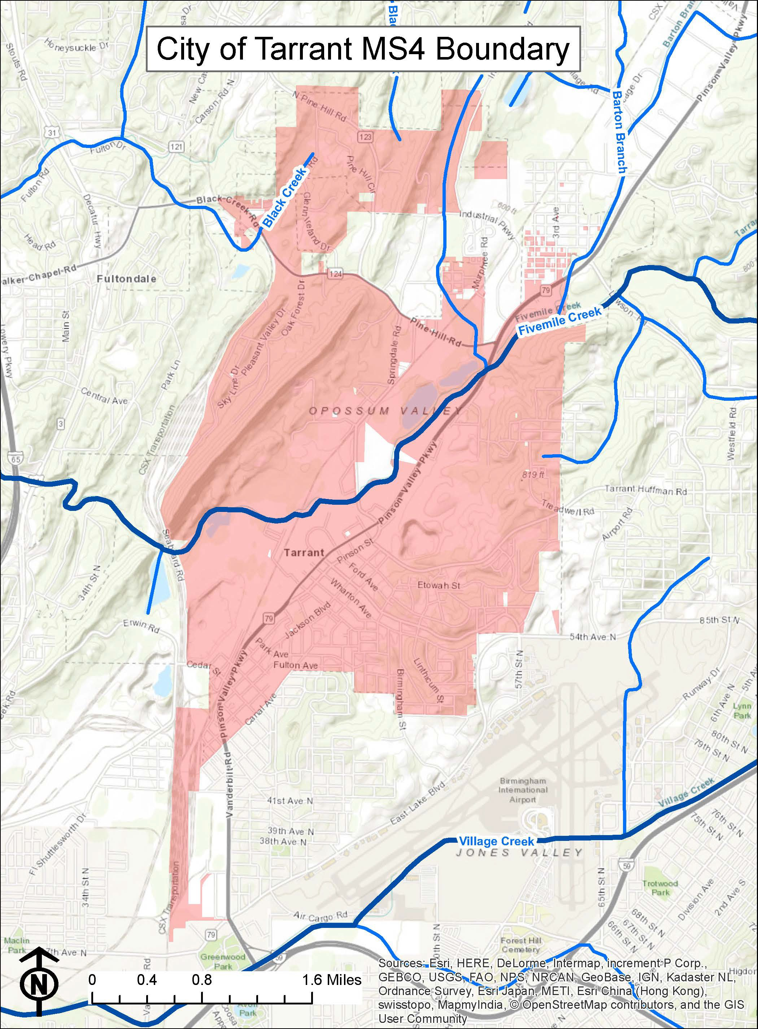
Figure 1: MS4 Boundary

Storm Water Collection Systems Operations

Structural Controls Mapping
The City currently has no owned/maintained structural controls within the MS4 boundary limits. The City will monitor the addition of any City owned/ maintained structural controls.

Responsible Departments: Inspections/JCDH

Structural Controls Inspection
As stated in the permit, all existing and new structural controls owned/maintained by the Permittee shall be inspected on a semi-annual basis, at a minimum, using a standard inspection form found in Appendix B. A city inspector and/or a contractor will perform inspections. Any deficiencies or maintenance recommendations listed on the inspection form in regards to the structural control will be addressed by Public Works.
Responsible Department: Inspections

Standard Operational Procedure (SOP) for Structural Control Inspection and Maintenance Procedures
The standard inspection form found in Appendix B is used to document structural control inspections. Once any maintenance is completed, a city inspector and/or a contractor will re- inspect the Structural Control to ensure the structure can effectively function as designed.

Responsible Department: Inspections

Stabilization and Re-vegetation of Eroded Areas
During the inspection of the structural controls, areas of erosion will be documented. The Public Works Department will receive a copy of the inspection documentation noting the eroded areas and will stabilize and re-vegetate these areas.

Responsible Department: Public Works

Floatables, Litter, Sediment and Debris in Structural Controls
All floatables, litter, sediment, and/or debris found during the structural inspection will be documented. The Public Works Department will receive a copy of the inspection documentation and will remove the noted items. Public Works will maintain documentation of the estimated amounts of floatables, litter, sediment and debris removed during maintenance activities using the Storm Water Online Activity Record (SOAR) program.

Responsible Department: Public Works

Public Education and Public Involvement on Storm Water Impacts

Development and Implementation of the SWMPP
The City will seek public input on the SWMPP by posting the draft SWMPP on its website for comments. Notification announcements will be made at council meetings. The Council- approved SWMPP for the upcoming year will then be posted on the website and be submitted yearly with the Annual Report on January 31.
Responsible Department: Administration

Public Access to City Storm water Documents
The City has posted copies of the current Annual Report, current SWMPP and the NPDES permit on the City’s website. These documents will routinely be updated on the website whenever new ones are approved by the city council and/or submitted to ADEM.

Responsible Department: Administration

Targeted Pollutant Sources for Public Education
The City discusses targeted pollutant sources in the section of the SWMPP titled “Community Involvement with the Storm Water Program”.

Reduction of Litter Floatables and Debris
The City currently maintains litter signage within the City of Tarrant. Signage will be updated as necessary to properly address these issues. Administration approves of the messages and Public Works installs the signs and/or labels.

Responsible Departments: Administration/Public Works

Educating Individuals and Households on Reducing Storm Water Pollution
The City has posted on its website, information describing its Storm Water Program. The information includes general information about the storm water permit with links and brochures about different ways to reduce storm water pollution in relation to the different community segments. These same brochures on storm water issues are placed at City Hall for public pickup. These materials will be updated as needed.

Responsible Department: Administration

Community Involvement with the Storm Water Program

General Public
The City has a storm water page on its website and place in City facilities brochures containing information that informs the general public of:
- General impacts litter has on water bodies and ways to reduce the litter
- General impacts of storm water on surface water from impervious surfaces
- Source control BMPs in areas of pet waste, home vehicle maintenance, landscaping and rain water reuse.
- Impacts of illicit discharges and how to report them.
These materials will be updated as needed.

Responsible Department: Administration

Businesses
The City has a storm water page on its website and placed in City facilities brochures containing educational information on the following business-related topics:
- Information on BMPs for use and storage of automotive chemicals, hazardous cleaning supplies, carwash soaps and other hazardous materials.
- Impacts of illicit discharges and how to report them.
These materials will be updated as needed.

Responsible Department: Administration

Homeowners, Landscapers, and Property Managers
The City has a storm water page on its website and placed brochures containing educational information in City facilities that inform homeowners, landscapers, and property managers on the following topics:
- BMPs and storage of pesticides, herbicides, and fertilizers.
- Detention/retention pond maintenance.
- General impacts of storm water from impervious surfaces into surface water.
These materials will be updated as needed.

Responsible Department: Administration

Engineers, Contractors, and Developers
The City has a storm water page on its website and placed brochures containing educational information in City facilities that inform engineers, contractors and developers on the following topics:
  - Impacts of increased storm water flows into receiving water bodies.
  - Run-off reduction techniques and low impact development (LID)/green infrastructure practices. Specifically addressing site design, pervious pavement, alternative parking lot design, retention of forests and mature trees.
These materials will be updated as needed.

Responsible Department: Administration

Evaluating the Effectiveness of the Public Education Program
The City will evaluate the effectiveness of the public education program by monitoring and reporting the number of visitors to the storm water page and the number of brochures that are picked up from the City facilities on an annual basis.

Responsible Department: Administration

Public Awareness Activities
Currently the City is planning to host or participate in a cleanup annually. The tonnage collected by the City will be included in the Annual Report.

Responsible Department: Administration

Illicit Discharge Detection and Elimination (IDDE)

MS4 Map
Maps of the major outfalls and waters of the State within the MS4 boundary that receive discharge from the major outfalls can be found in Appendix C. Also, a list of the major outfalls’ latitude and longitude coordinates can be found in Appendix C.
JCDH will update the MS4 map and provide a list of location coordinates annually on behalf of the City.

Responsible Department: JCDH

Ordinance/Regulatory Mechanism
Ordinance No. 1108 addresses illicit discharges as required by the City’s Permit.

Responsible Department: Administration

Dry Weather Screening
Dry weather screening of 20% of the stream miles will be performed annually with 100 percent of the major outfalls screened at least once per the five year permit period. This work will be completed by JCDH. Currently there are no priority outfalls identified within the MS4 boundary, but if illicit discharges are identified during the dry weather inspections, those outfalls will be screened on an annual basis. JCDH shall use the EPA’s guidance manual, Illicit Discharge Detection and Elimination, A Guidance Manual for Program Development and Technical Assessments, Center for Watershed Protection, October, 2004, for the main source of investigative techniques and guidance for the dry weather screening process. Outfalls will be field inspected after a minimum of 72 hours of dry weather. Data sheets found in Appendix C will be filled out for each outfall inspected. The protocols for dry weather screening are in the Standard Operating Procedure Manual found in Appendix A.

Responsible Department: JCDH

Source Identification
If during the dry weather screenings, Public Works’ identification, or citizen complaint, an outfall is found to be discharging a liquid, the city inspector or JCDH personnel will traverse upstream of the discharge in an attempt to identify the source of the discharge. If the discharge source is unidentifiable, then a sample of the discharge shall be collected by JCDH and analyzed by a qualified lab. Based on the lab results, the outfall will be prioritized and scheduled for further investigation if needed.

Responsible Departments: City Personnel/JCDH

Illicit Discharge Elimination
Once the source and responsible party of an illicit discharge has been identified, either the City will take action through Ordinance No. 1108 or JCDH will through its regulations.
Responsible Departments: Code Enforcement Officer or JCDH

ADEM Notification by the City
If a suspected illicit discharge enters the City’s MS4 boundary from an adjacent MS4, the City will notify the adjacent MS4 and the ADEM Water Division within 48 hours of observing the suspected illicit discharge. The Standard Operating Procedure for this action is found in Appendix C.

Responsible Department: Inspections

Illicit Discharge Reporting by the Public
The City receives calls for illicit discharges at the City Hall phone number 205-849-2800 ext. 1031 for the Mayor or ext. 1035 for the Building Inspection Department.

Responsible Department: Administration

Personnel Training
Non-First Responder City Personnel will be trained on IDDE identification and response annually.

Responsible Party: Administration

Ordinance/Regulatory Mechanism Availability
All ordinances and regulatory mechanisms can be found on the City’s website, www.cityoftarrant.com.

Responsible Department: Administration

Construction Site Storm Water Runoff Control

Erosion and Sedimentation Control Complaints
The City frequently receives calls about construction and sedimentation runoff at the City Hall phone number (205-849-2800). These calls are directed to the Department of Building Safety and Inspections (205-849-2800 ext. 1035). The website lists the Department of Building Safety and Inspections as the contact number for construction complaints.

Responsible Department: Inspections

Site Plan Reviews
According to Ordinance No. 1107 a BMP plan must be submitted to the City along with the permit application before the commencement of any land disturbance. The City must either approve or disapprove the BMP plan within 14 days. Reasons for disapproval must be submitted to the applicant in writing. All revisions have an additional 14-day response time. Land disturbing activity may not be commenced prior to the issuance of the permit by the City.

Responsible Departments: Inspections/Engineering

Site Inspection Plan
The City will perform a monthly inspection, at a minimum, on qualifying sites that have been issued land disturbance permits. Erosion controls and best management practices will be inspected during these inspections. Deficiencies identified during an inspection will be subjected to enforcement procedures outlined in the Ordinance No. 1107.
Responsible Department: Inspections

Training of MS4 Site Inspection Staff
Personnel responsible for construction site inspections receive BMP training annually.

Responsible Department: Inspections

Construction Site Inspection Checklist
See Appendix D for the City’s construction site inspection checklist.

Responsible Department: Inspections

Enforcement Response Plan (ERP)
An Enforcement Response Plan is included in Ordinance No. 1107.

Responsible Department: Administration

Construction Site Operator Training
The City provides construction site operator’s informational materials regarding appropriate application and maintenance of erosion and sediment controls when they receive their permits from the Inspections Department. The City has a storm water page on its website that also contains educational information informing the engineers, contractors and developers on:
  - Impacts of increased storm water flows into receiving waterbodies.
  - Run-off reduction techniques and low impact development (LID)/green infrastructure practices. Specifically addressing site design, pervious pavement, alternative parking lot design, retention of forests and mature trees.
These materials will be updated as needed.

Responsible Departments: Administration/Inspections

Post-Construction Storm Water Management in New Development and Re-Development

Ordinance/Regulatory Mechanism
City Ordinance No. 1109 meets the requirements for post-construction storm water management.
The Post-Construction Ordinance addresses the following:
- Procedures to develop, implement and enforce systems of appropriate structural and/or non-structural BMPs.
- Procedures to develop, implement and enforce performance standards.
- Procedures for encouragement of the utilization of LID/green infrastructure practices.
- Procedures to ensure compliance including sanctions and enforcement mechanisms.
- Procedures for post-construction inspections to include tracking and enforcement.
- Procedures to ensure adequate long-term operation and maintenance of BMPs.

Responsible Department: Administration

Inventory of Post-Construction Structural Controls
The City is developing a list of privately-owned structural controls for those built after the codification of the new requirements. Currently the City has none. The City will update annually the list of privately-owned structural controls under the new requirements.

Responsible Department: Inspections

Spill Prevention and Response

City Response Protocol
The Tarrant Fire and Rescue is responsible for investigating, responding, and conducting response actions for any spill within the City’s boundaries. Jefferson County’s Emergency Management Agency (EMA) will additionally respond at the request of the City. Tarrant’s Fire and Rescue and EMA track the spills, the response, and the cleanup activities for all spills.

Responsible Department: Fire and Rescue

Spill Prevention/Spill Response Plan
The City’s SOP for spill response is found in Appendix E.
Responsible Department: Fire and Rescue

Personnel Spill Prevention/Response Training
Tarrant Fire and Rescue is responsible for the training and certification of their personnel. An annual training will be provided to municipal personnel on spill prevention/response.

Responsible Department: Fire and Rescue/Administration

Pollution Prevention/Good Housekeeping For Municipal Operations

Municipal Facilities Inventory
See Table 1: Municipal Facilities for a list of facilities. The list will be reviewed annually and updated as needed.

Responsible Departments: All Departments

Good Housekeeping Practices SOP
The SOP detailing good housekeeping practices is found in the 2011 SWMA SOP Manual. (Appendix A).

Responsible Departments: All Departments

Inspection Plan
Annual inspections will be conducted for municipal facilities that have the potential to discharge pollutants vial stormwater runoff. See Appendix F for a list of sites to be inspected and the inspection checklist.

Responsible Departments: All Departments

Good Housekeeping Training Program
City staff will be educated annually on good housekeeping practices. The 2011 SWMA SOP Manual contains procedures related to Good Housekeeping.

Responsible Department: Administration

Short Term and Long Term Trash Removal Strategy
The City has a SOP for special events that promotes the reduction of trash and debris into the City’s MS4 as well as Waters of the State (Appendix F).

Responsible Department: Administration
Table 1: Municipal Facilities
Name | Address | Inspection
Tarrant Electric | 701 Clow Rd | Yes. Equipment Storage
Public Works | 791 Elizabeth Ave | Yes. Equipment Storage
Public Works | 2529 Commerce Way | Yes. Vehicle/ Equipment Storage
Tarrant Electric | 2538 Commerce Way | Yes. Vehicle/ Equipment/ PHF Storage
Public Works | 2533 Commerce Way | Yes. Equipment Storage
Public Works | 2515 Commerce Cir | Yes. Vehicle/ Equipment Storage
Public Works | 803 Elizabeth Ave | Yes. Equipment Storage
Public Works | 799 Elizabeth Ave | Yes. Equipment Storage
Public Safety | 2593 Commerce Cir | Yes. Vehicle Storage
Parks And Rec. | 1232 Faye Dr | Yes. Vehicle Storage
City Hall | 1133 East Lake Blvd | No. No potential to discharge pollutants.

Application of Pesticides, Herbicides, and Fertilizes (PHFS)

Application and Storage
The Park and Recreation Department keeps annual records of applied pesticides, herbicides, and fertilizers (PHFs). Each chemical used is applied per the labeling instructions. Per the SOP, City staff only sprays when there is a three-day window of no rain. Safety Data Sheets (SDS) on each product are found in the chemical storage areas. City staff responsible for application of PHFs receive annual training in safe use, storage, and disposal of PHFs. All contractors contracted to apply pesticides or herbicides to City property shall provide proper certification and licensing before performing work. Also, contractors contracted to apply fertilizer must provide qualification in utilizing proper nutrient management practices. The City is also in the process of developing a program to detect proper usage (Figure 2: PHF's Usage Sites).
City facilities that store PHFs will be inspected annually to determine proper storage, product labeling, and SDS accessibility (T: Municipal Properties). The SOP manual contains procedures related to usage and storage of PHFs (Appendix A).

Responsible Department: Parks and Recreation

PHF Training Program
City staff will be educated annually on proper PHF practices.

Responsible Department: Administration
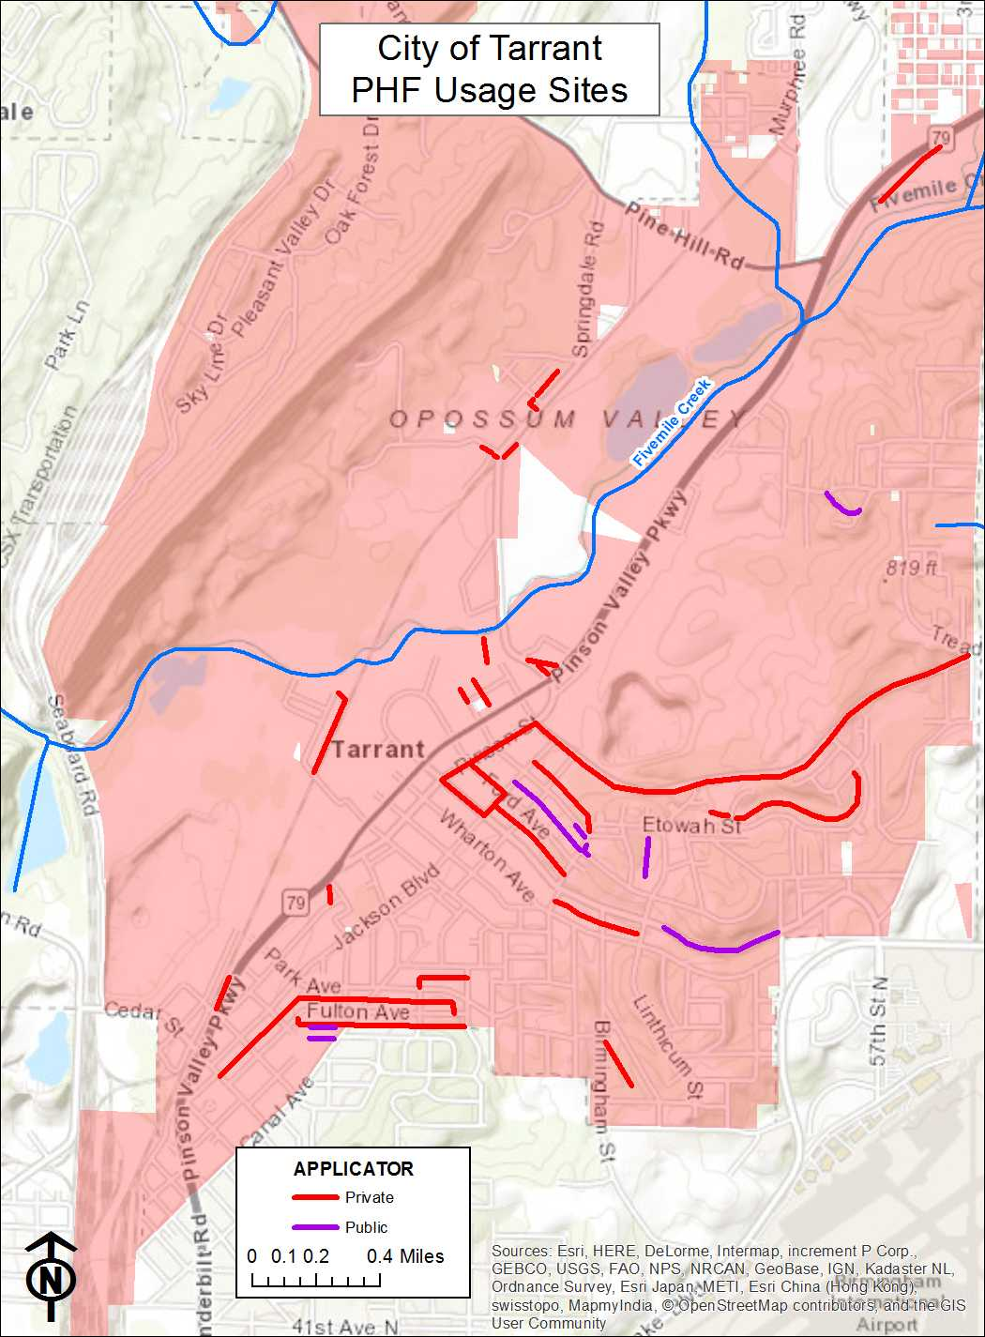
Figure 2: PHF Usage Sites

Oils, Toxics, and Household Hazardous Waste

Public Education on Proper Disposal
The City has contact information on its website regarding where to report spills, illicit discharges and improper disposals. The website Earth911 http://earth911.com/ can be used to find a location near you for recycling of oils, toxics and household hazardous waste. Brochures on oils, toxics, and household hazardous waste are on the City storm water website as well as placed in City facilities for public pick-up.

Responsible Department: Administration

Annual Employee Training
Annual training on spill prevention is provided to City personnel.

Responsible Department: Administration

Industrial Storm Water Runoff

Inventory of High Risk Facilities
The City maintains a list of industrial and high risk facilities within the city limits (Appendix G). The list of industrial facilities will be reviewed annually for accuracy and will be updated when necessary. A map of the industrial and high risk facilities can be found in Figure 3: Industrial and High Risk Facilities.

Responsible Departments: Administration/JCDH

Inspection of High Risk Facilities
JCDH will inspect these sites annually on behalf of the City. See Appendix G for the Industrial Inspection form.

Responsible Department: JCDH
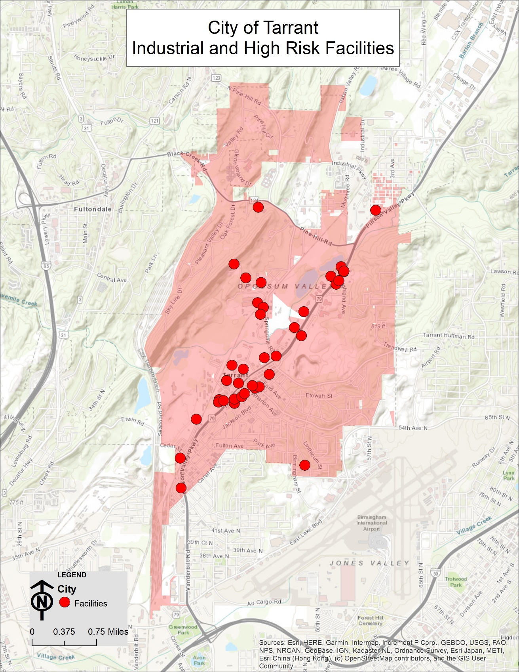
Figure 3: Industrial and High Risk Facilities

Wet-Weather Monitoring and Reporting

Monitoring Locations
JCDH will take wet-weather grab samples at sites annually on behalf of the City. See Figure 4: Tarrant Sampling Sites for a map of the sampling sites
The site locations are as follows:
Water Body | Latitude, Longitude | Description
Five Mile Creek | 33.588181,-86.790431 | Grab Sample

Responsible Department: JCDH

Impaired Waterways
The City will review the water bodies listed in the latest final §303(d) list, annually. If a water body becomes listed that falls within the MS4 boundary, the SWMPP will be updated as needed.

Responsible Department: JCDH

Monitoring Parameters and Frequency
Grab samples will be analyzed for the following parameters:
  - E.coli
  - Total Nitrogen (TN) (mg/l)
  - Total Phosphorus (mg/l)
  - Total Suspended Solids (TSS) (mg/l)
  - Temperature
  - pH/ORP
  - Turbidity (NTU)
  - Conductivity
  - Dissolved Oxygen (mg/l)
  - Ammonia Nitrogen (NH3-N) (mg/l)
  - Biochemical Oxygen Demand (BOD) (mg/l)
  - Chemical Oxygen Demand (COD) (mg/l)
  - Hardness as CaCO3 (mg/l)
  - Nitrate plus Nitrite Nitrogen (NO3+NO2-N) (mg/l)
  - Oil and Grease (mg/l)
  - Total Dissolved Solids (TDS) (mg/l)
  - Total Kjeldahl Nitrogen (TKN) (mg/l)

Responsible Department: JCDH

Sampling Type Collection and Analysis
JCDH will collect grab samples and submit them to a certified laboratory for analysis.

Responsible Department: JCDH
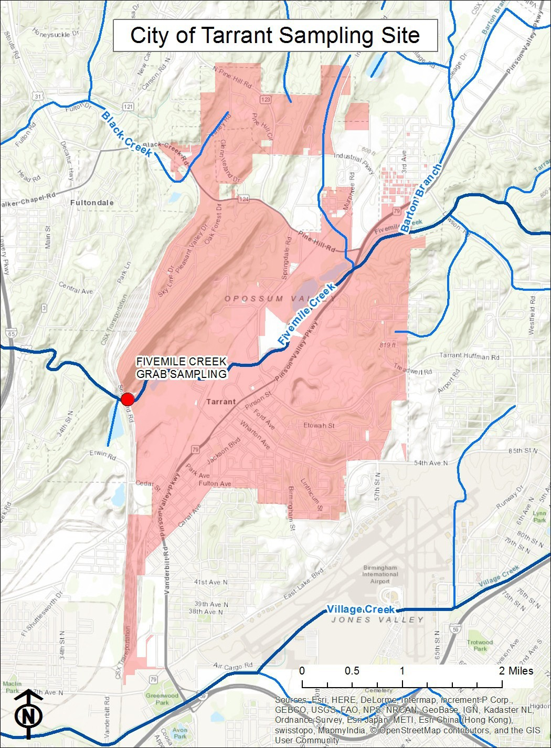Figure 4: Sampling Sites

Other Requirements

SWMPP Plan Review and Modification
This plan will be reviewed annually and updated as necessary.

Responsible Departments: All Departments

Annual Report
The Annual Report will be compiled by JCDH for the City of Tarrant.

Responsible Department: JCDH

